MD2201: Data Science

Name of the student: Bhagwat Vinod Kolekar Roll No. 58

Div: ET-B Batch: B3

Date of performance:

Experiment No.6

Title:Classifier Performance
Aim: To measure the different performance parameters of a classifier.

Software used: Programming language R.

Data Set: Wisconsin Breast Cancer data set

Code Statement:

Apply KNN to the Wisconsin Breast Cancer data set. Split the data into training and testing samples. Scale the data and find the following

- Accuracy
- Sensitivity
- Specificity
- Precision

Code: (Write code for above statements here)

f1<-read.csv("wbc_csv.csv")

#shuffle data
set.seed(123)
f1<-f1[sample(nrow(f1)),]

#normalizing the data (concept of pre processing )
#normalization of b = (b-min(b))/(max(b)-min(b))
f1_new<-f1[,3:32]
n<-function(b){
(b-min(b))/(max(b)-min(b))
}
f1_nor<-as.data.frame(lapply(f1_new,n))
class(f1_nor)

#spliting the data into training and testing
#knn
f1_train<- f1_nor[1:469,]
f1_test <- f1_nor[470:569,]
f1_trainlable <- f1[1:469,2]
f1_testlabel <- f1[470:569,2]
library(class)
p<- knn(f1_train,f1_test,f1_trainlable,k=7)
#p is predicted data

t <- table(actual=f1_testlabel,predicted = p)
print(t)

# Finding performance parameters
acc <- sum(diag(t)/sum(t))
cat("Accuracy is: ",acc)

# for calculating sensitivity
sen<-t[2,2]/sum(t[2,])
cat("\nsensitivity is :",sen)

#for calculating specificity
spe<-t[1,1]/sum(t[1,])
cat("\n Specificity is :",spe)

#for calculating precision
pre<-t[2,2]/sum(t[,2])
cat("\nPrecision is :",pre)

Results: Display the output obtained on R console for all he cases.

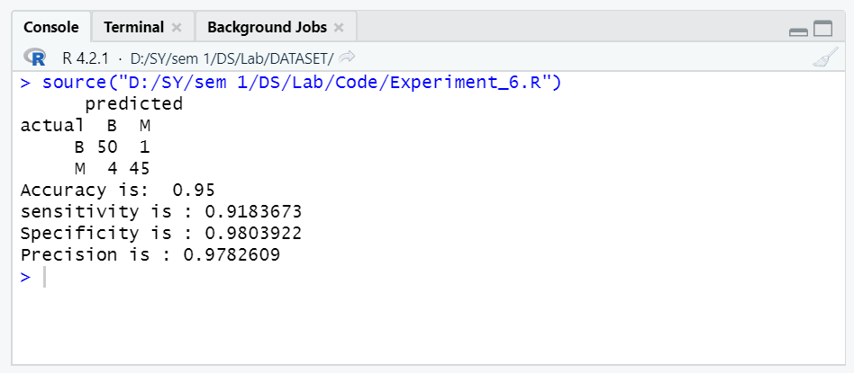

Conclusion: (Write the conclusion in your words. Write the values you obtained for all metrics).

In this question values of confusion matrix is –
true negative value is 50
false positive value is 1
false negative value is 4
true positive value is 45

Accuracy is 0.95
Sensitivity is 0.91
Specificity is 0.98
Precision is 0.978

